INFORMATIONAL CALL SCRIPT
For COVID-19 case patient outreach to provide information about staying at home, treatment, and resources.
Overall Guidelines for this Conversation:
- Be sure to personalize the call to sound approachable and friendly and help build a personal connection with the case patient. In addition, you may add "Good Morning," "Hi," or another welcome phrase to start the call.
- Your outreach here can make a significant difference in this individual’s situation – take your time. You do not need to rush.
- Meet the person where they are while on the call – curb your enthusiasm!
- This is about accompaniment: active listening, empathy, and collaboration.
- Always use a warm, welcoming, confident tone of voice, and remember you are here to help. We want to ensure these individuals receive the support, resources, and information they need.
- You do not need to have every answer to all possible questions, but you can help connect people to others who have answers.

This document provides an outline of the steps and content to cover when providing stay at home, treatment, and resource support for someone believed or confirmed to have COVID-19. To jump to a particular section, click the hyperlinks below while holding the CTRL key on your keyboard:
Section 1: Preparing for the Outreach 1
Section 2: Introducing Yourself and Purpose for Call 2
Section 3: CDC Guidance on When to Stay Home 4
Section 4: Information for Case Patient’s Close Contacts 5
Section 5: Treatments for COVID-19 5
Section 6: Resource Referrals 6
Section 7: Wrapping Up 7
Section 8: Supplemental COVID-19 Vaccine Information 9

Section 1: Preparing for the Outreach
Before you reach out to this individual, prepare for the conversation.
Review the individual’s:
- Name
- Date of birth – You will need to adapt the script if the case patient is a minor:
- If under 13 years of age, you must be speaking with a legal guardian to continue the call.
- If above age 13 and younger than 18, you must speak to a legal guardian first. With permission from the legal guardian, you may continue the call with the case patient.
- Diagnosis Date

Review the following guidance and information:
- COVID-19 Vaccine Information – Ensure you are up to date on COVID-19 vaccine guidance, recommendations, and how to talk to case patients about barriers and vaccine hesitancies. See Section 8: Supplemental COVID-19 Vaccine Information
- COVID-19 Treatment Information – Review current treatment options at the following link: https://www.cdc.gov/coronavirus/2019-ncov/your-health/treatments-for-severe-illness.html
- Support Resources – Ensure you are aware of what local and state resources are available to COVID-19 case patients

Section 2: Introducing Yourself and Purpose for Call
IF THERE IS A RESPONSE:  “Hello, my name is [insert your name] and I am a member of North Carolina’s Public Health Outreach Team. I am calling on behalf of the Division of Public Health. May I speak with [insert case patient’s first name]? Pause for response.  IF THERE IS NO RESPONSE (VOICEMAIL SCRIPT):  “Hello, this is [insert your name] and I am a member of North Carolina’s Public Health Outreach Team. I am calling on behalf of the Division of Public Health for [insert case patient’s first name] regarding a public health matter. We would like to speak with you to provide some further information as well as help connect you to resources and other assistance you might need.  IF LHD: At your earliest convenience, please give us a call back at the [insert name of local health department] at [insert phone number] or at our statewide call center at (844) 628-7223. Their hours are 9am to 5pm, Monday through Friday. If you leave a voicemail outside of this time, it will be returned within 24 hours. Again, I am [insert your name] calling from the [insert name of local health department] regarding a public health matter. Thank you.”  IF CCTC: At your earliest convenience, please give us a call back through the statewide call center at (844) 628-7223 between 9am to 5pm, Monday through Friday. If you leave a voicemail outside of this time, it will be returned within 24 hours. Again, the number for the call center is (844) 628-7223, and I am calling from North Carolina’s Public Health Outreach Team, on behalf of the Division of Public Health. Thank you.” | If the person is not the individual you were trying to reach, ask to speak with the correct person. If the number is wrong, apologize for the inconvenience and end the call.  If the person who answers asks what the NC Public Health Outreach Team is or its validity, encourage the person to visit https://www.ncdhhs.gov/divisions/public-health/contact-tracing  If the case patient voluntarily notifies you they live in a different NC county than noted in CCTO, please update their county in CCTO.  If the case patient voluntarily notifies you they are not a NC resident, ask for their address and add it in CCTO. If they refuse to provide an entire address, collect as much information as the case patient is willing to provide. Complete ICO and assign monitoring event to Jennifer Wheeler.
ESTABLISHING PREFERRED LANGUAGE:  “Could I please confirm, is English your preferred language?”  IF English IS the case patient’s preferred language:  “Thank you. And is this the best phone number to reach you?”  IF English is NOT the case patient’s preferred language:  “I’d like for you to be able to speak to someone in the language in which you are most comfortable speaking. May I call you back in just a few minutes with someone who can help us with that?” | If the case patient confirms that English is not their preferred language, continue according to CCTC or local health department direction. If the person cannot understand you, enunciate and convey in simple language that someone will call them back.
IF PERSON WHO ANSWERS IDENTIFIES AS A STAFF MEMBER AT A CONGREGATE SETTING FACILITY AND STATES THEY ARE NOT ABLE TO TRANSFER YOU DIRECTLY TO THE CASE PATIENT:  “I am calling to share public health information as we have received report that a person at your facility has tested positive for COVID-19. Since I will not be speaking to the case patient directly myself, I want to make sure your facility is able to provide the information, such as current CDC guidance and treatment opportunities, to anyone at your facility who has tested positive for COVID-19. Can I review that information with you or is there someone else it would be more appropriate for me to speak to? If yes, staff will continue with this script and modify as needed.  “Please know this call is intended to ensure the case patient is aware of current information. I am not able to advise you on what steps your facility may need to take in response to the individual(s) testing positive, as that would be a conversation with your local health department. If you have two or more people who test positive at your facility within 14 days, please remember to call your local health department to report the cluster or outbreak and discuss next steps.” | If the phone number on the case patient’s monitoring event belongs to a congregate setting facility, please create a task and assign it to the “CCNC – CORT” team in CCTO.  If the congregate setting asks for more information regarding cluster or outbreak, please refer them to NCDHHS Updated Guidance on Reporting COVID-19 Outbreaks and Clusters.
IF THE CASE PATIENT IS NOT AVAILABLE TO TALK:  “Is there a better time for me to call back?” OR  “Sounds like this isn’t a good time for you. When would be a better time?” OR  “Sounds like you’re not feeling up to talking right now. Can you predict a better time?”* Pause for response and document.  “Or, if you would prefer, is there someone else who might be available who has your permission to speak to me about your illness?”** | The case patient might be sleeping, resting, or at work. Wait for a response, thank the person, document, and schedule an outreach for the designated time.  *If you need to call back later, document the requested time to call the case patient back and set a calendar reminder to call back.  **If the case patient provides a proxy, document the name of the person with whom you are speaking and that person’s relationship to the case patient.
IF THE CASE PATIENT OR LEGAL GUARDIAN IS AVAILABLE:  “I am calling to share public health information as well as help connect you to resources and other assistance you might need at this time. The call should take no more than 10 minutes.  “Would you mind verifying your date of birth, so I can ensure that I have the right person on the phone? Please know that any information you give me during our conversation is confidential.”*  “Thank you for verifying your information. It might be best for us to speak in private. Are you somewhere this is possible? Pause for response. I can give you a moment if you need to go somewhere else to be comfortable.” | *You can verify the person’s identity using any identifying information available in CCTO. If the case patient is reluctant to confirm identity, encourage them to Google the number from which you are calling and see that it is legitimate; to call back to the call center (844-628-7223) between 9am to 5pm Monday-Friday and listen to the automated prompt; or (as a last resort) to call the LHD to confirm the call is legitimate. If the case-patient is ultimately unwilling or unable to confirm their identity, the call cannot continue. Do not mention that you are calling about a COVID-19 diagnosis unless the identity has been confirmed.
IF THE CASE PATIENT TRIES TO END THE CONVERSATION BY SAYING THEY ARE VACCINATED:  IF case patient voluntarily informs you that they have been vaccinated,  “Thank you for sharing. I have some more information to share that may help while you are navigating through this challenging time.” *  IF case patient questions why they tested positive for COVID-19 even though vaccinated,  “That’s a great question. There are many possible reasons, and I can go over a few more common reasons as to why people who are vaccinated against COVID-19 may still get the disease. Breakthrough infections are much more likely with newer strains of COVID-19. Vaccines are highly effective, but a small percentage of individuals do not develop the expected antibody response to vaccines. Also, vaccines may decrease severity of illness without preventing all infections. Finally, if you received the vaccine recently you could have already been incubating the virus at the time of vaccination. Please keep in mind that these are not all the possibly reasons why. Thank you for telling me you are vaccinated and I would like to go over some more vaccine information at the end of the call to ensure you are up to date. | *Keep in mind this individual may not be up to date with their COVID-19 vaccine recommendations.

Section 3: CDC Guidance on When to Stay Home
“I am calling today because we understand that you have recently been diagnosed with COVID-19. I have noted here in our system that you were tested on [insert diagnosis or specimen collection date]. Is this correct?”
“What can you tell me about your recent COVID-19 diagnosis?  IF THE OPEN-ENDED QUESTION ABOVE DOES NOT ANSWER THE FOLLOWING QUESTIONS, PLEASE ASK:  “Have you been experiencing any symptoms?”  “Do you work in a healthcare setting?” | Wait for response. Listen carefully, reflect, ask case patient to elaborate, and summarize as appropriate. The case patient may convey valuable information about the symptoms that caused them to seek medical care, or alert you to exposures that inspired them to get tested.
IF CASE PATIENT IS SYMPTOMATIC:  CDC recommends that you stay home and away from others until your symptoms are improving and you have been fever free (without fever reducing medicine) for at least 24 hours. Once resuming normal activities, it is recommended you consider ways to reduce the spread of disease for five more days. This includes taking more steps for cleaner air, enhancing hygiene practices, wearing a well-fitting mask, keeping a distance from others, and/or getting tested for respiratory viruses. Enhanced precautions are especially important to protect those most at risk for severe illness, including those over 65 and people with weakened immune systems. More information about these precautions can be found on CDC’s website*.  IF CASE PATIENT IS ASYMPTOMATIC:  If you develop any symptoms, CDC recommends that you stay home and away from others until your symptoms are improving and you have been fever free (without fever reducing medicine) for at least 24 hours. Once resuming normal activities, it is recommended you consider ways to reduce the spread of disease for five more days. The following precautions should also be taken for five days from your test date if you never develop symptoms. This includes taking more steps for cleaner air, enhancing hygiene practices, wearing a well-fitting mask, keeping a distance from others, and/or getting tested for respiratory viruses. Enhanced precautions are especially important to protect those most at risk for severe illness, including those over 65 and people with weakened immune systems. More information about these precautions can be found on CDC’s website.  IF CASE PATIENT WORKS IN A HEALTHCARE SETTING:  CDC offers separate guidance for people who work in a healthcare setting. For more information on when you can return to work in a healthcare setting, please reach out to your employer and/or review CDC’s webpage titled “Interim Guidance for Managing Healthcare Personnel with SARS-CoV-2 Infection or Exposure to SARS-CoV-2.”** | The case patient should be aware of when they can be around others again:  - Their symptoms are improving for at least 24 hours  - It has been 24 hours with no fever (without fever-reducing medications such as Tylenol, Ibuprofen, Advil, Naproxen)  *Please check this link often to make sure you are up to date on guidance:  https://www.cdc.gov/respiratory-viruses/guidance/respiratory-virus-guidance.html  Additional Prevention Strategies: https://www.cdc.gov/respiratory-viruses/prevention/index.html  Risk Factors for Severe Illness from Respiratory Viruses:  https://www.cdc.gov/respiratory-viruses/risk-factors/index.html  **Guidance for cases working in a healthcare setting: https://www.cdc.gov/coronavirus/2019-ncov/hcp/infection-control-recommendations.html  If the phone number on the case patient’s monitoring event belongs to a congregate setting facility, please create a task and assign it to the “CCNC – CORT” team in CCTO.

Section 4: Information for Case Patient’s Close Contacts
“Letting people know they've been exposed to COVID-19 helps your family and community. Think about who was near you (within 6 feet) for a total of 15 minutes or more in a 24-hour period since [insert 2 days before symptom onset or test date if asymptomatic]. These people would be considered your close contacts. You may want to reach out to them directly or you can anonymously notify them by entering their information using a trusted website called tellyourcontacts.org.  “You can let any of your close contacts know that they can call the NC Public Health Outreach Team call center at (844) 628-7223 to speak to someone if they have any questions or want help in finding a testing location. Additionally, if you’re interested, I can provide you testing information now that you could pass along to them.” IF YES, see testing information on the right*. | *Testing Information:  https://covid19.ncdhhs.gov/FindTests

Section 5: Treatments for COVID-19
“Next, I’d like to give you some information about your treatment options for COVID-19 that may help you feel better faster and could help prevent hospitalization. Would you be interested in hearing more?”  IF INTERESTED IN LEARNING MORE:  “Currently, there are two oral antivirals available which can be found at most local pharmacies. The two antivirals are called Paxlovid and Lagevrio (molnupiravir).  Oral antiviral treatments are medicines that fight the virus that causes COVID-19 and can be given to you in the form of a pill. These medications can be helpful for people who are at a higher risk for severe infection and hospitalization. The treatments are authorized for high-risk individuals with COVID-19, which may include those over 50 years old or people with conditions like heart disease, obesity, COPD, moderate to severe asthma, diabetes, or anything that may result in a weakened immune system.  COVID-19 treatments do not replace the benefit of COVID-19 vaccines. Vaccines still provide the best protection against severe disease and death; however, these treatments are options that may prevent hospitalization for some patients if taken within five days after symptoms start.  If you’d like to learn more about treatment, to discuss your eligibility, or simply to ask any questions you may have about treatment, you can speak to a healthcare provider. For more information, you can:  - Visit https://covid19.ncdhhs.gov/treatment to find a Test to Treat location. At a Test to Treat location, you can get tested, be evaluated by a healthcare provider, and – if treatment is right for you – get treatment all in one visit. Some locations may offer services free of charge or at reduced cost for the uninsured. If you go to that website, you can find a number that is local for you to call.  - Call the CDC’s COVID-19 treatment call center (see right).  Does all of that make sense?” (Pause for response).  “Thank you for speaking with me about these treatment options. If it’s alright with you, we can now move ahead to talk about any resources you may need.”  IF NOT INTERESTED IN LEARNING MORE:  “Not a problem. If you would like to learn more at any time, you can visit https://covid19.ncdhhs.gov/treatment for information, but please remember the antiviral pills work best when taken as soon as you feel sick and have a positive diagnosis. If it is alright with you, we can now move ahead to talk about any resources you may need.” | Review current treatment options at the following link: https://www.cdc.gov/coronavirus/2019-ncov/your-health/treatments-for-severe-illness.html  For information, FAQs and find treatment location: https://covid19.ncdhhs.gov/treatment  For information about COVID-19 treatment, call:  - 1- 800-232-0233 (English & Spanish)  - 1-888-720-7489 (TTY)

Section 6: Resource Referrals
“Now, I would like to ask you about what kind of resources you might need or how we may be able to assist you with some of the challenges of staying home.”  Invite the Individual to Share  “We know it is a difficult time for many people right now, and we want to make sure that we are doing a good job of serving our community. We would like to understand what issues and concerns people might be facing and what we can do to better support our community.  “I’m curious are there any barriers that you may experience as you approach staying home from work, or working from home, during your stay home period? (Pause for response).  “Are you in need of any resources to be able to stay home during this time? This support could look like food, baby supplies, mental health support, etc.  Pause and listen. When the individual has finished, reflect on the response, and confirm your understanding. | Pause for response.  - Always use a warm, welcoming, confident tone of voice.  - It is important to remember that everyone is different. Some will be receptive and others will be hesitant or uninterested.  - Give them a moment to comment or acknowledge they understood.  Be positive and supportive. Individuals should know that we are here to make sure they are informed and receive the support, resources, and information they need.
IF A RESOURCE NEED IS IDENTIFIED  “Thank you for sharing that with me. It is important that you get the help you need. If you have time, I would like to talk more about resources at the end of our call to hopefully connect you with the best organization to meet your needs. This will extend the time you are on the phone with us. Is that alright with you or would there be a better time for us to call you back?”  IF WILLING TO DISCUSS ON CALL  “Wonderful. At the end of our conversation, we can continue to talk about resources.”  IF REQUESTS A CALL BACK:  “I can call you back at your preferred time. You should expect to receive a call back in the next day or so. Please be on the lookout for a call from NC Public Health Outreach Team at 1-844-628-7223.”  IF NOT WILLING TO DISCUSS ON CALL  “That is alright. You can always call or text 2-1-1 to learn about resources available to you. If you decide you want to call us back later to talk about resources, you can call a resource specialist at 844-628-7223 between 9am to 5pm Monday-Friday. If you call outside of these hours, you can leave a voicemail and someone will return your call within 24 hours” | At the end of the call, open the NCCARE360 Resource Referral Script to continue the conversation.
IF A RESOURCE NEED IS NOT IMMEDIATELY IDENTIFIED OR IF SOMEONE ELSE IS IN NEED  “Thank you for sharing that with me. If you think of any support you or your family needs due to COVID-19, please call our NC Public Health Outreach Team Call Center at 844-628-7223 between 9am to 5pm, Monday-Friday. If you call outside of these hours, you can leave a voicemail and someone will return your call within 24 hours.” | Take your time and listen with empathy. Individuals may be experiencing major life events, such as job loss, loss of a loved one, illness, or food insecurity.

Section 7: Wrapping Up
“What other questions can I answer for you now?”  “If at any time your symptoms worsen, and you experience shortness of breath, your lips or fingertips are turning blue, you start feeling sleepy or sluggish, or if you have a fever of more than 102˚ Fahrenheit and it is not reducing, please call your medical provider or 911, and let them know you have COVID-19, so that they can provide immediate and appropriate care.”  “In order for me to provide you with the current vaccine guidelines and help keep you and your community safe, I’m curious – have you received the COVID-19 vaccine?”  IF VACCINATED*:  “Since you’ve been vaccinated, can you tell me a little bit more about your COVID-19 vaccine history so I can see if you are up-to-date and provide you with correct information? See right for applicable up-to-date vaccine information.  “Are there any questions I can answer or resources I can provide you to help the people around you who might not have been vaccinated yet?”  IF NOT VACCINATED**:  “Before we get off the phone, we want to reach out and let everyone in our area know that the COVID-19 vaccine is free, safe, and available to anyone who would like to receive it. Since you have COVID-19 now, you will need to wait to get the vaccine until your stay home period has ended. Getting vaccinated after your stay home period is over will help to protect you against severe disease, hospitalization, and death***. Or if you are generally healthy and low risk for disease, you may wait 3 months from [insert 10 days from symptom onset or test date if asymptomatic] as reinfection is less likely in the weeks to months after this infection. I’m curious; what are your thoughts on the vaccine(s)?” Pause for response. Refer to Section 8. Supplemental COVID Vaccine Information.  CLOSING THE CALL:  If you think of any questions after this call has ended or any resources that you may need, you can contact the NC Public Health Outreach Team Call Center at (844-628-7223) between 9am to 5.pm, Monday-Friday. Anyone who answers can help you. If you call outside of these hours, you can leave a voicemail and someone will return your call within 24 hours.”  “Thank you for your time today and for answering my questions. We are here to help so please do not hesitate to reach out with any questions during this challenging time.” | Allow the case patient to respond; answer accordingly.  Have the case patient repeat the symptoms you have listed and need to monitor.  *CDC website on updated shot information: https://www.cdc.gov/coronavirus/2019-ncov/vaccines/index.html  **If they have not been vaccinated, listen and reflect on their response. If they are willing to discuss more with you, continue to the Supplemental COVID-19 Vaccine Information when you finish your conversation.  ***More information on vaccine effectiveness can be found here: https://covid.cdc.gov/covid-data-tracker/#vaccine-effectiveness

Section 8: Supplemental COVID-19 Vaccine Information

To make sure you have the most up to date CDC information and guidance regarding the COVID-19 vaccine, please refer to the following websites:
- Stay Up to Date with Vaccines
- How to talk about COVID-19 Vaccines
- Understanding how COVID-19 Vaccines Work
- CDC's Myths and Facts about COVID-19 Vaccines

Additional Resources
- Frequently Asked Questions about COVID-19 vaccines
- Chat online with a robot that can answer your COVID-19 vaccine questions
- To find vaccines near you, you can:
    - Visit myspot.nc.gov
    - Call 1-800-232-0233
    - Text your zip code to 438829

Basic COVID Vaccine Info
- There are three FDA authorized COVID-19 vaccines in the U.S today
- The COVID-19 vaccine is free, safe, effective and recommended for everyone over 6 months old.
- Getting vaccinated is the best way for us to keep our community safe from severe illness/hospitalization due to COVID-19.

Have you received any COVID-19 vaccines so far?

Yes
No

Since you’ve been vaccinated, can you tell me a little bit more about your COVID-19 vaccine history so I can see if you are up-to-date and provide you with correct information?

That is not a problem. I respect your decision and am not here to push you at all. There can be a lot of different reasons why people are hesitant to get the vaccine. It is helpful for the state to be aware of those different reasons, so that we can better understand our community. Would you feel comfortable telling me a little about your own reasons? I am here to listen, try to understand, and only offer information if you want it.

No
Yes
That’s alright. I appreciate your time. If you do have any other questions later about the COVID-19 vaccines, feel free to call a health care provider you trust or your local health department.
Yes
Thank you for being willing to talk more with me about this. Which vaccine did you most recently receive and when did you receive it? I can wait if you need to go get your vaccination card.
Click here to see CDC’s COVID-19 Vaccine Schedule
Thank you for being willing to talk more with me about this. Can you tell me more about your reasons to not get vaccinated?

Click below to find talking points on common vaccine hesitancy reasons:
- Cost  - Don’t need it (I’m healthy/ just had COVID)  - Don’t need it (nobody gets COVID anymore)  - Microchip/No govt. trust  - Safe for kids? | - Came out too fast (is it safe?)  - Does it work?  - I don’t know/something else  - Side effects  - Immunocompromised  - Pregnant/ Breastfeeding/ Fertility

Vaccine Hesitancy and Confidence Building Conversations
Click if questioning whether to get an updated (bivalent) dose
One of the primary barriers is vaccine hesitancy, a personal choice to delay or refuse getting vaccinated. When talking to contacts and cases, it may be helpful to understand some common reasons for hesitancy and how to engage in dialogue with those individuals. Some identified reasons and possible responses are listed below.

I’m worried about the cost of the vaccine.

- The COVID-19 vaccine is free for everyone! No proof of insurance or ID is required to receive the vaccine (NC DHHS).

I don’t think I need the COVID-19 vaccine. (Either) I’m young and healthy (or) I just recently had COVID-19 so now I have natural immunity, right?

- The Omicron variant is very contagious; anyone is susceptible to contracting the virus and possibly having symptoms. The virus can be spread by asymptomatic individuals (CDC).
- Re-infection can happen and new variants of the virus continue to be discovered (CDC).
- Individuals who have previously had COVID-19 infection are less likely to become reinfected if they are fully vaccinated (CDC).

I’m worried about the side effects of the vaccine.

- Some patients do experience mild side effects after receiving the vaccine. However, the possible side-effects are minor in comparison to the chance of you, or a loved one, contracting COVID-19 and becoming seriously ill (CDC)
- Side-effects do not include contracting COVID-19 or other serious health conditions (CDC)
- Research indicates that getting the vaccine is the best way to protect yourself from serious side effects, hospitalization and death due to COVID-19 (CDC)

I have a health condition and am concerned about my safety.

- If you have concerns about a specific health condition, you should consult your doctor.
- Individuals with moderate or severe immunocompromising medical conditions are at increased risk of becoming seriously ill or even dying from COVID-19, so getting vaccinated is especially important for these individuals (CDC).
- You can self-attest to your moderate or severe immunocompromised status. There is no paper documentation needed to receive a vaccine or booster (CDC).

No one is really getting COVID-19 anymore, so I don’t need the vaccine.
- People are still contracting COVID-19 across the state and country (CDC)
- People that are unvaccinated account for the majority of hospitalizations and deaths due to COVID-19 (CDC)

I don’t want a microchip implanted in me. (or) I don’t trust the government.

- The COVID-19 vaccine doesn't contain any technology including microchips or software. All vaccine ingredients are publicly listed on the FDA and CDC websites. (CDC)
- The COVID-19 vaccines were not developed by the government, but rather by private companies with long-standing reputations for providing safe and effective vaccines. (CDC)

The vaccine was developed so quickly. I want to wait and see if it’s safe.

- The quick development of the vaccine was not due to any corner-cutting and followed the standard FDA approval process as every vaccine before (CDC).
- More than 56 million people have received an updated (bivalent) COVID-19 vaccine (CDC)
- Researchers had previously been studying coronaviruses for years and were able to get a head start in the development based on that research (CDC)
- To make sure the vaccine is safe, CDC expanded and strengthened its ability to monitor vaccine safety (CDC)

I am pregnant, breastfeeding or thinking of becoming pregnant in the near future and I have concerns about how the vaccine may affect me and/or my child.

- The vaccine is recommended for people who are pregnant, breastfeeding, or trying to get pregnant in the future. (CDC)
- People who get COVID during pregnancy are more likely to get very sick or have complications (CDC)
- Studies show that COVID-19 vaccination did not affect women’s likelihood to get pregnant (PubMed) or increase the risk of miscarriage (when vaccinated before 20 weeks) (CDC)
- If you would like to speak with someone about COVID-19 vaccination during pregnancy or breastfeeding, you can contact MotherToBaby, whose experts are available to answer questions in English or Spanish by phone or chat. Call 1-866-626-6847 M-F, 8-5pm or go online to https://mothertobaby.org/contact/

- Vaccines for children are safe and effective. (CDC)
- Why Children And Teens Should Get Vaccinated (CDC)
- Children receive a smaller dose of the vaccine than teens or adults (CDC).
- Millions of Americans ages 5-17 have received the COVID-19 vaccine (American Academy of Pediatrics)
- 6 Things to Know About COVID Vaccination for Children (CDC)

Getting the vaccine for myself is one thing. Vaccinating my child is another thing. I’m too scared to risk it.

I don’t think the vaccine works.

- Unvaccinated adults were 5.3x more likely to be hospitalized due to COVID-19 than their up-to-date, vaccinated counterparts. (CDC)
- The COVID-19 vaccine has proven to be highly effective, cutting down on infection and hospitalization (CDC)

I don’t know why I don’t want to (or) it’s something else.

It’s okay. Your opinions are valid and at the end of the day, it is your decision whether or not to be vaccinated. I am here to support you. Do you have any questions for me?
Would it be alright with you if I share a little bit of information about the vaccine?
If yes, click here for basic information about the COVID-19 vaccine.
If no, Thank you for your time and if you have any other questions you can call your local health department or health care provider.

I have previously received the original COVID-19 vaccine(s), but I am not sure I want or need the updated (bivalent) vaccine. Does it really matter?

That is great that you received the primary series of the COVID-19 vaccine! That will provide you some protection. However, the CDC recommends that everyone 6 months of age and older receive the updated bivalent vaccine which helps protect against the most recent variant. Similar to the flu vaccine, it is important to receive regular booster shots because immunity wears off with time and new variants emerge that might not be as protected by a previous vaccine. Does that make sense?
Would you like to learn how to schedule your updated dose today?
If yes, click here
If no, thanks for your time. You can always call or go online later if you decide you want to.
Offer to give info if they want it:
1.) Visit myspot.nc.gov 2.) Call 1-800-232-0233 or 3.) Text zip code to 438829

Addressing Barriers to Vaccination
Barrier: Possible Intervention:
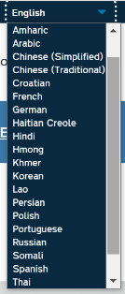
Lack of transportation | - Call your local transit authority for a free ride to your vaccine appointment. You may need to call in advance to schedule a ride.  - Ask your vaccine provider about transportation options
No computer/internet/smart phone | - Call 1-800-232-0233 to connect with someone who can help you schedule a vaccine appointment.
Can’t take time off work to go | - Appointments are available in evenings & on weekends. (Check pharmacies)  - In case you have minor side effects, you may want to get vaccinated before a day off.
No primary care doctor | - You don’t need to have a PCP! Many pharmacies & the LHD are vaccinating  - If you have medical questions, you can call CDC’s COVID-19 Vaccine Hotline at 1-800-232-0233
English language limitations | - https://covid19.ncdhhs.gov/vaccines  (Top right corner says “Select Language”)  - Phone # 888-675-4567 (interpreters available)

Recommended Vaccine Schedule For People Who Are NOT Immunocompromised

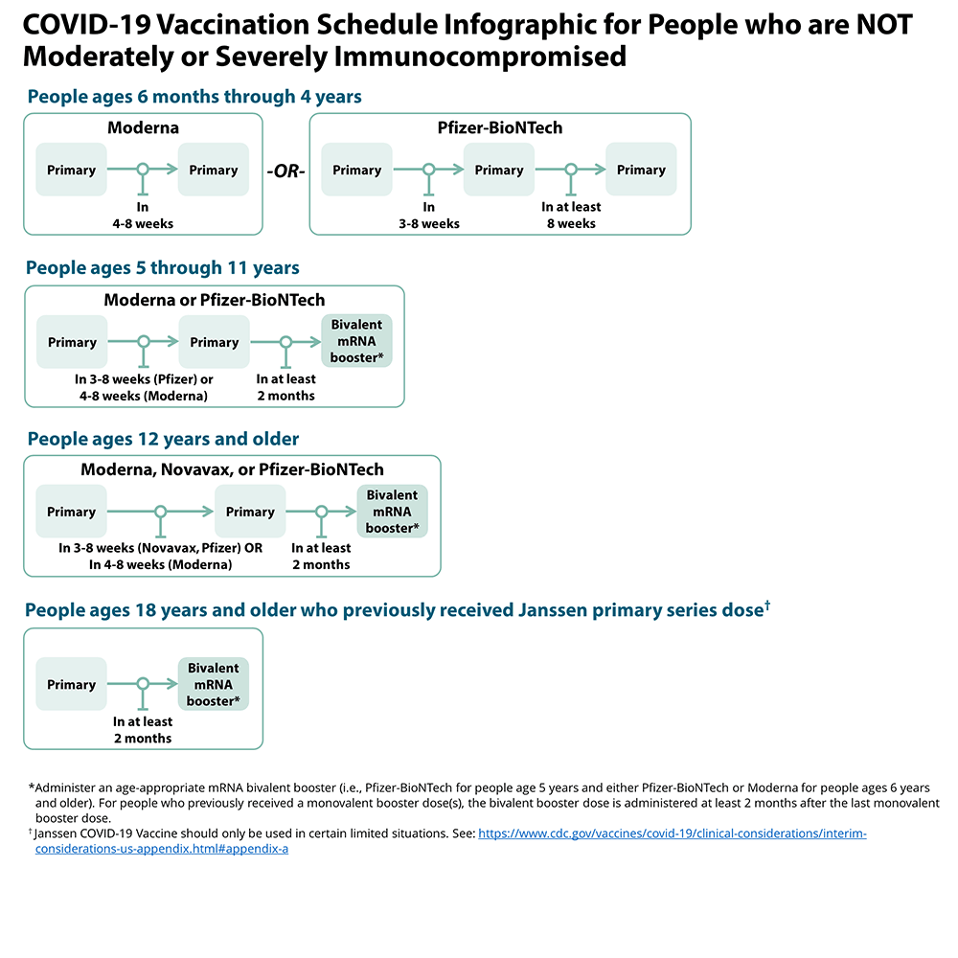

Recommended Vaccine Schedule For Immunocompromised People
